**BSEF17A559**

**IRDA MALIK**

**TASK 1**

1. sudo useradd jami
2. Sudo cat /etc/passwd & sudo cat /etc/shadow
3. Sudo passwd jamil
4. Sudo cat /etc/passwd & sudo cat /etc/shadow
5. Su jamil
6. Sudo cat /etc/default /useradd
7. Su root

Su jamil

1. Sudo passwd jamil
2. Chfn -f jamilfar jamil
3. Sudo cat /etc/passwd

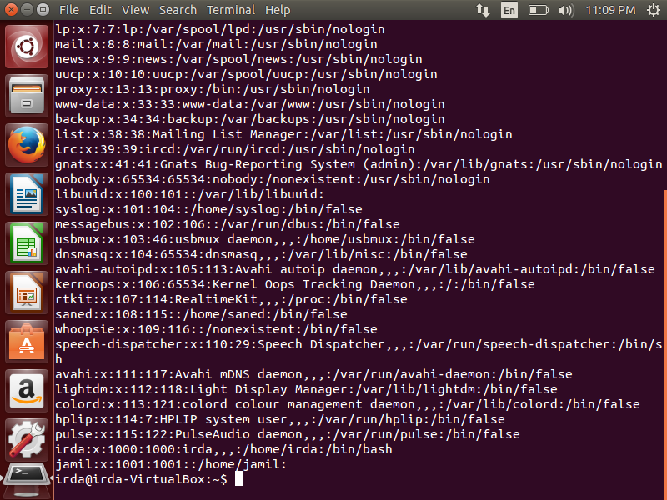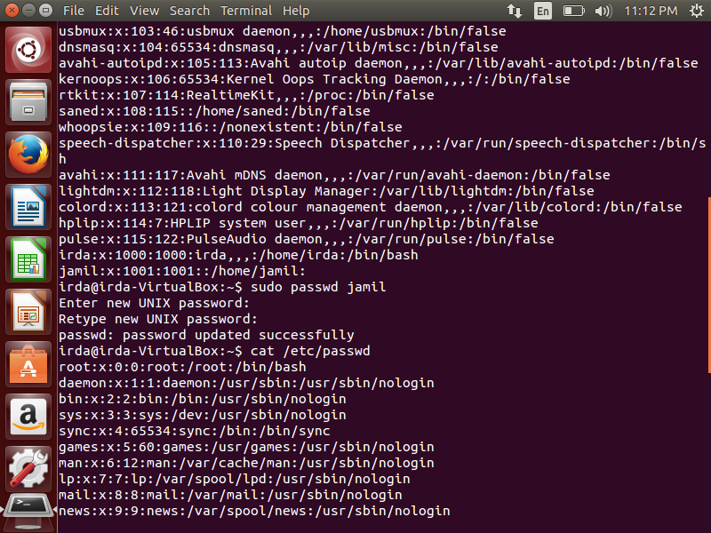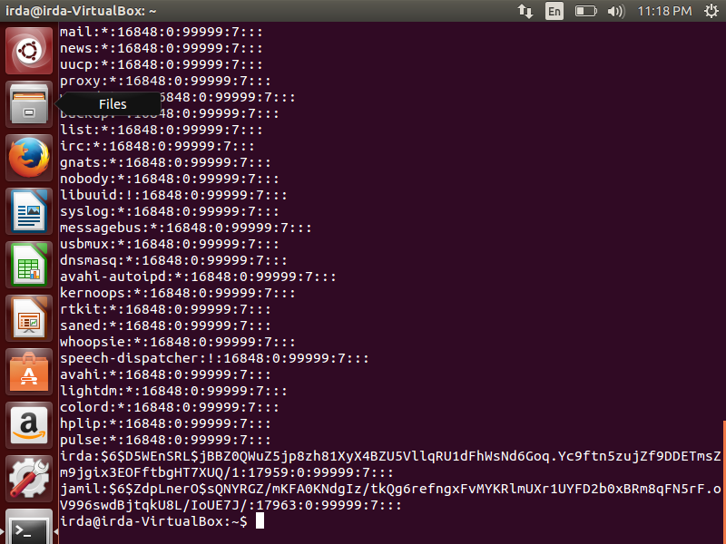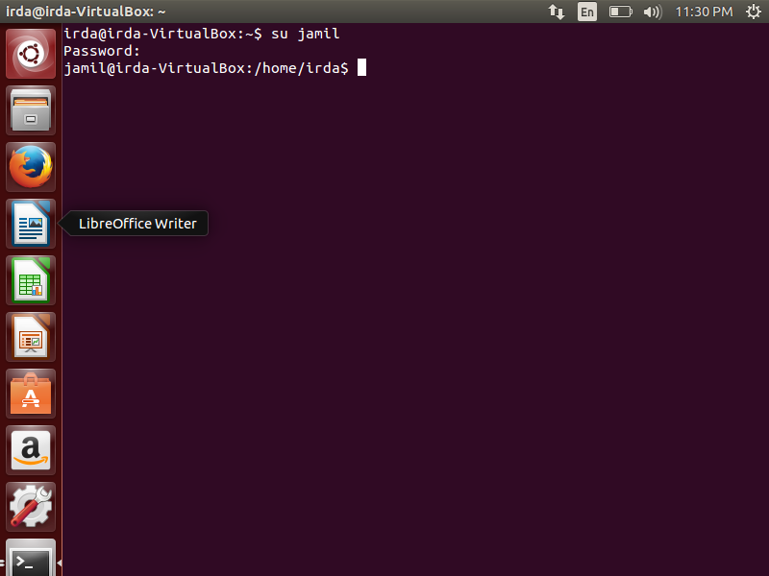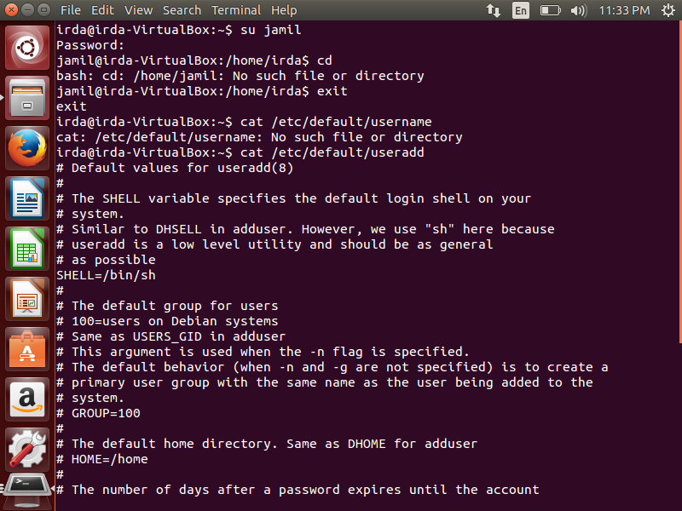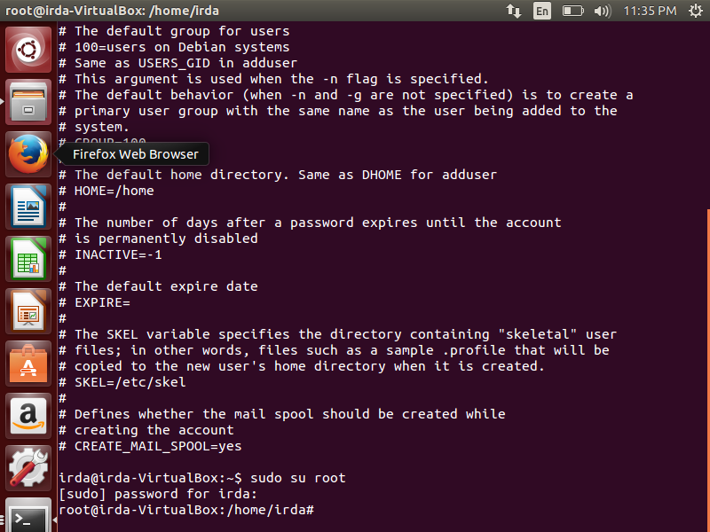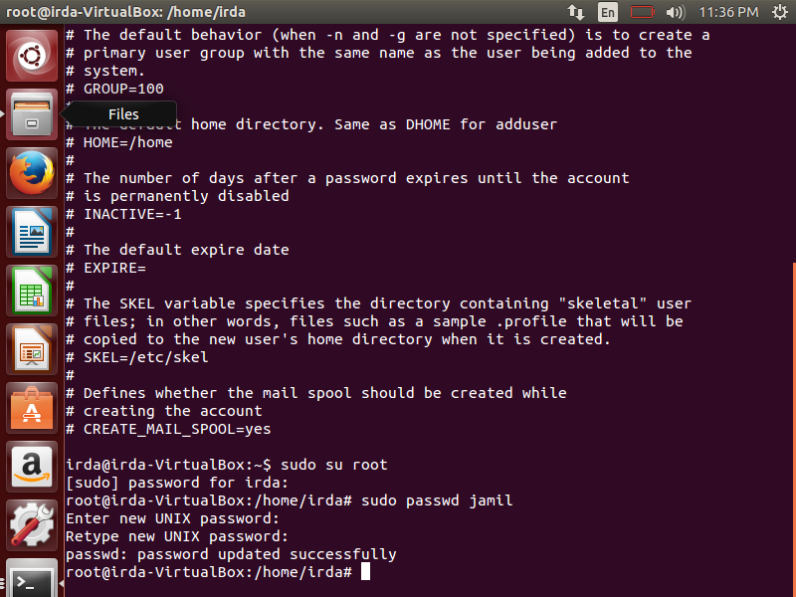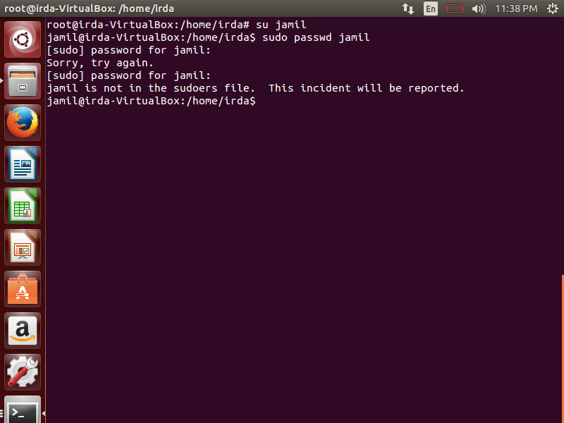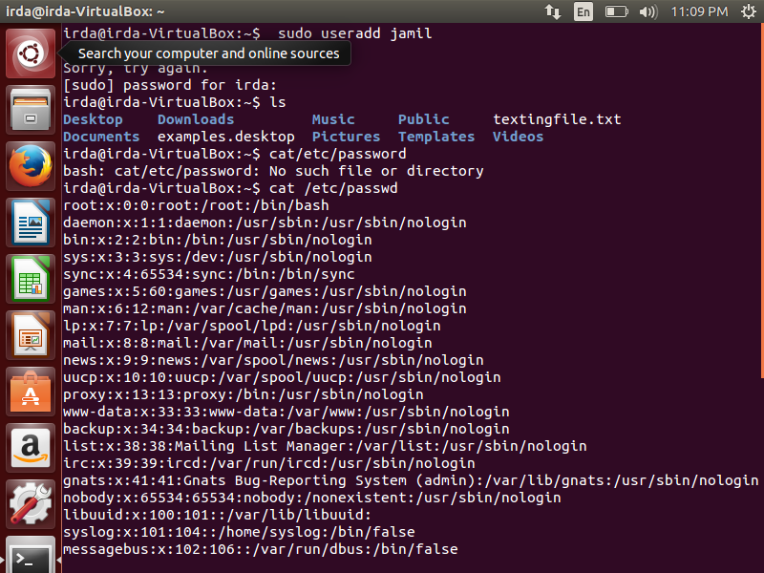

**TASK 2**

1. Sudo usermod -L Jamil

Su Jamil

1. Sudo usermod -U Jamil

Su Jamil

Sudo cat /etc/shadow

1. Sudo userdel Jamil

Su Jamil

E) sudo cat /etc/passwd

Sudo cat /etc/shadow

G) sudo usermod -l Farhan jamil

Su Jamil

Su Farhan

Pwd

1. Sudo cat /etc/passwd

Sudo cat /etc/shadow

Sudo cat /etc/group

j) sudo userdel -r Farhan

userdel -r Farhan

pwd

su Farhan

K) sudo cat /etc/passwd

Sudo cat /etc/shadow

Sudo cat /etc/group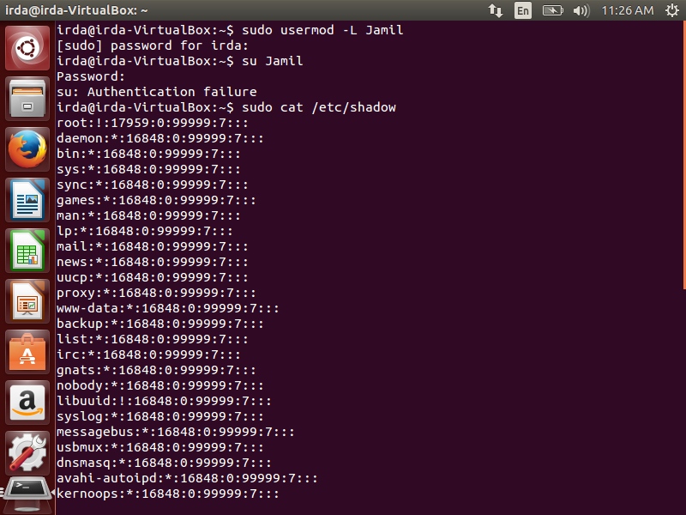

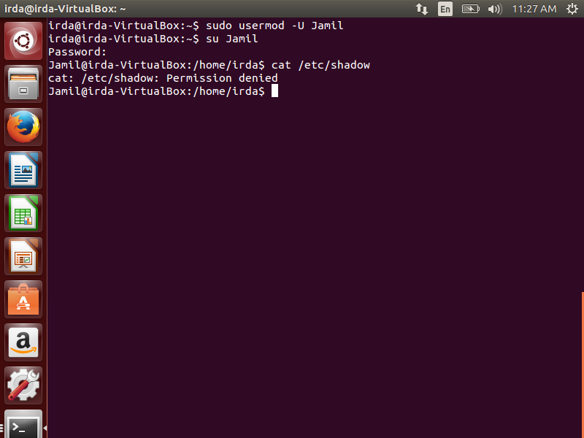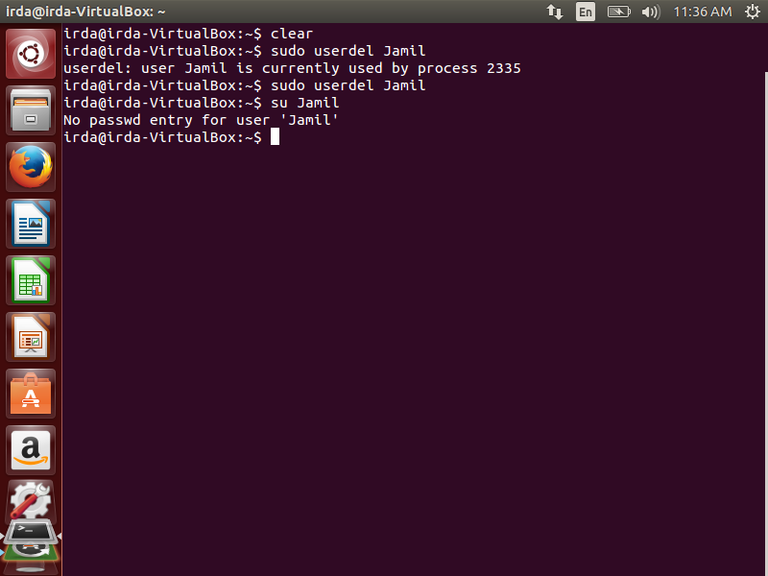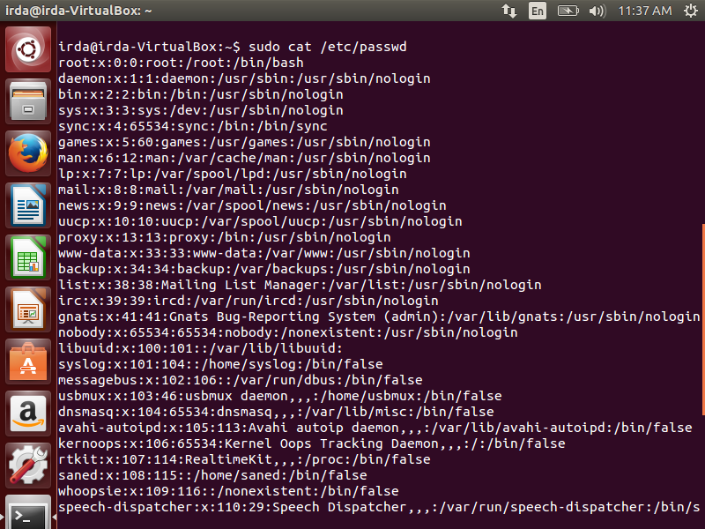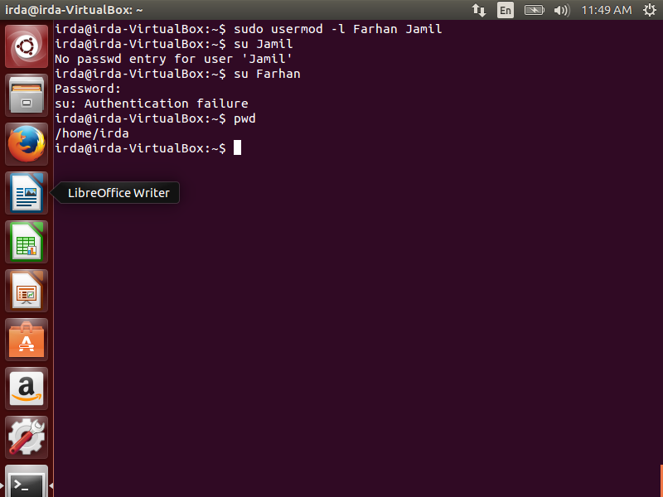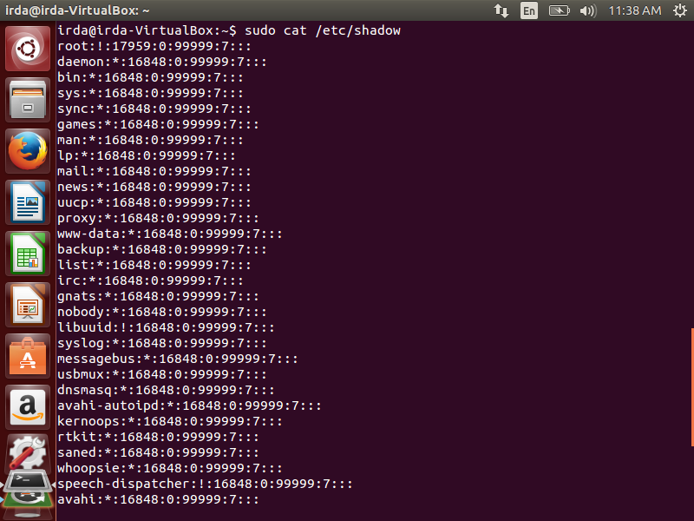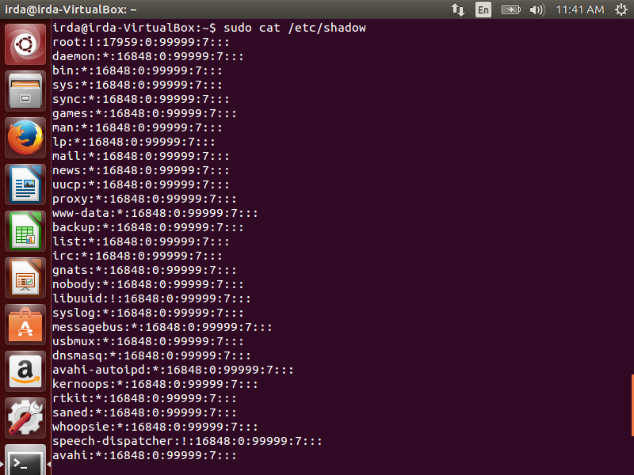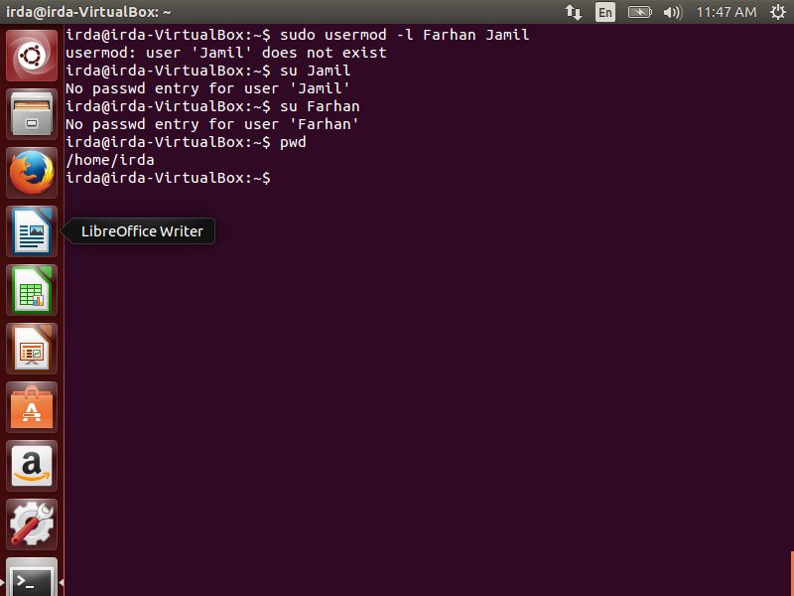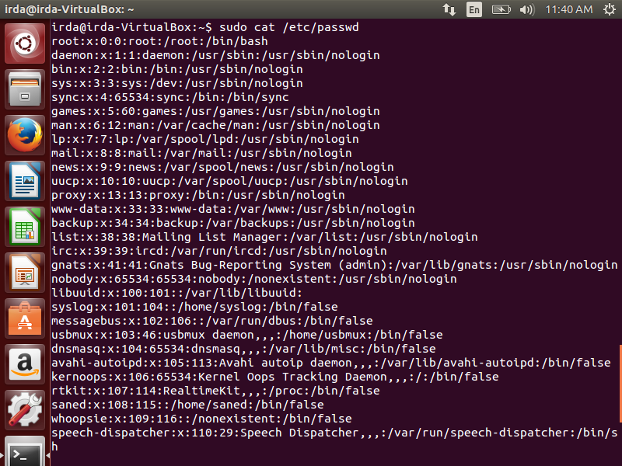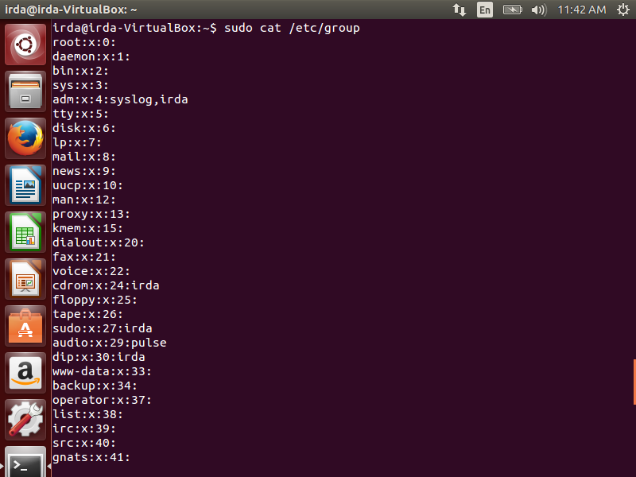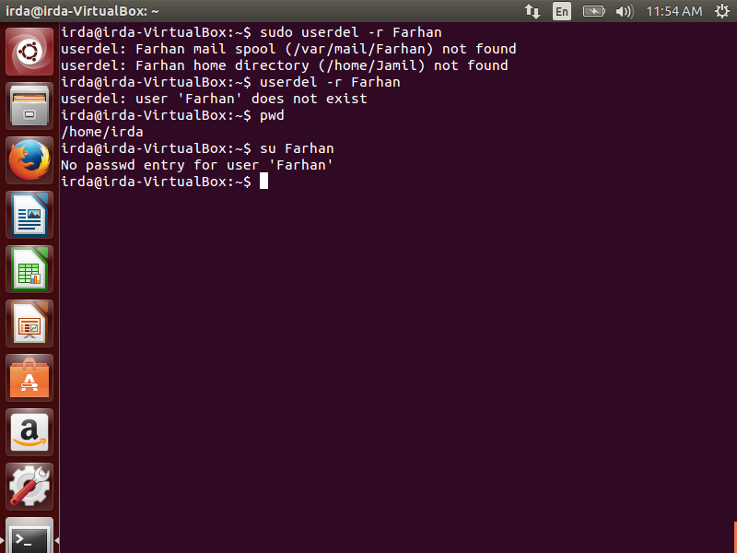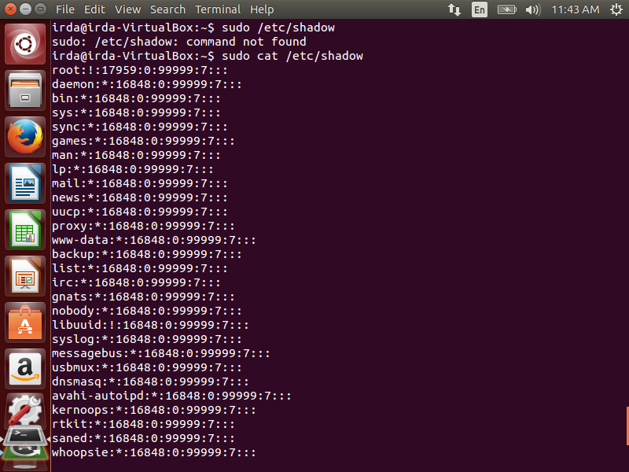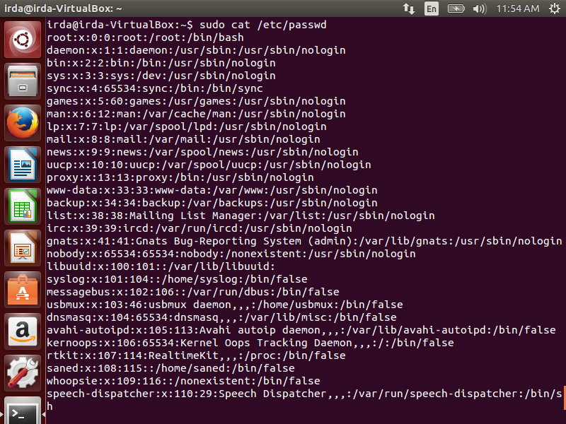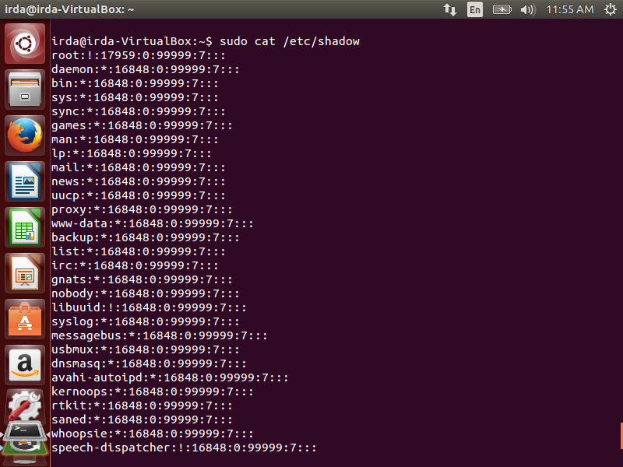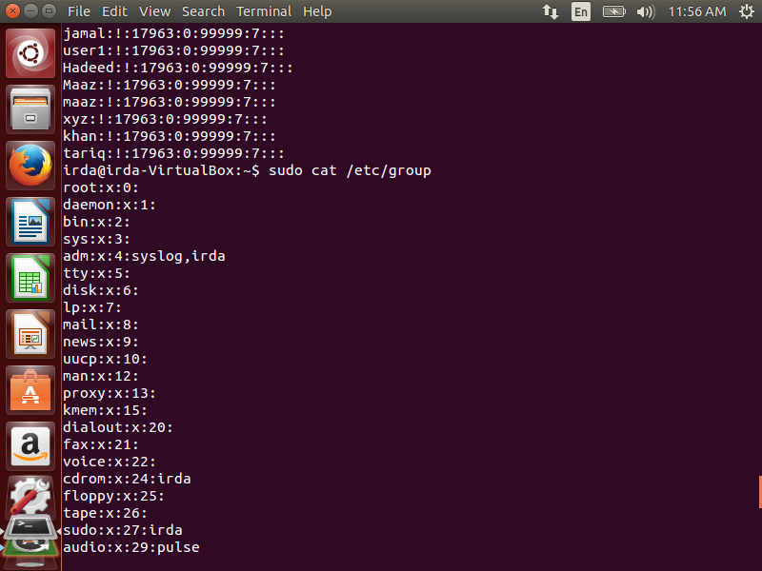

**TASK 3**

1. Sudo useradd Mansoor

Sudo passwd Mansoor

1. Sudo useradd Mansoor

D) sudo cat /etc/login.defs

e) sudo useradd Jamal

su jamal

F) sudo cat /etc/shadow

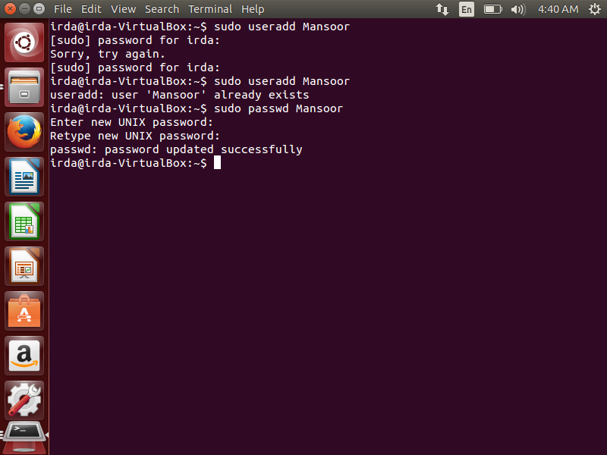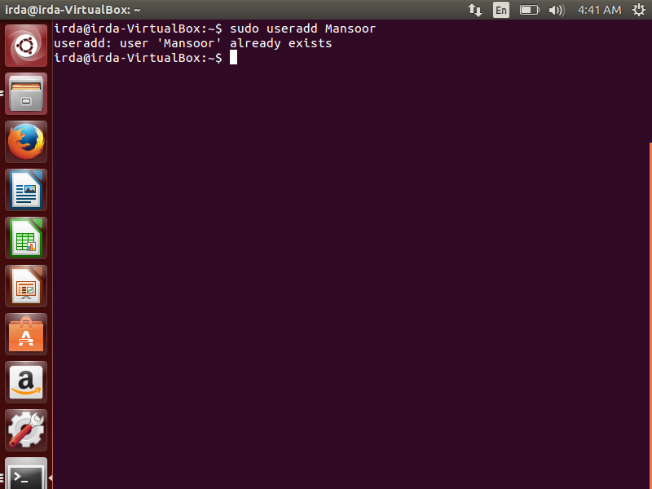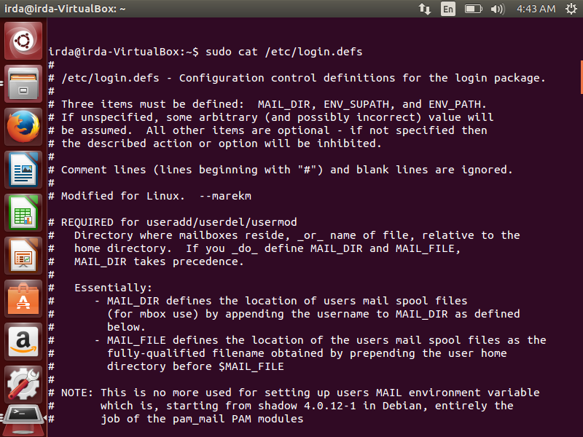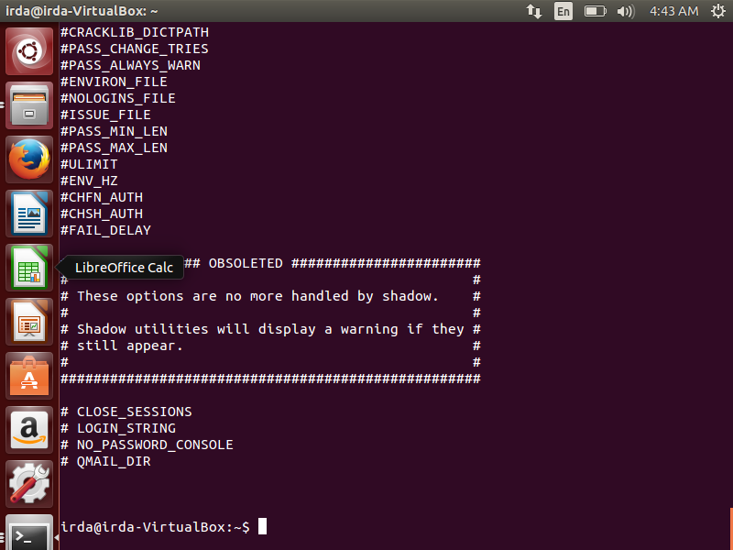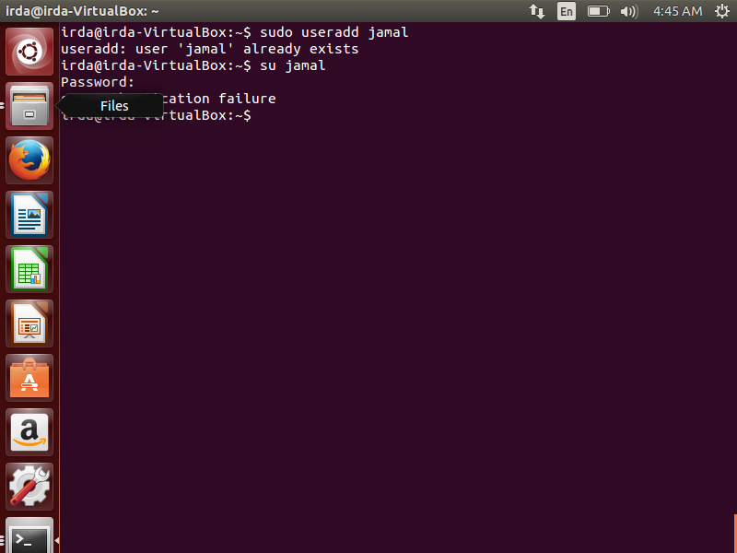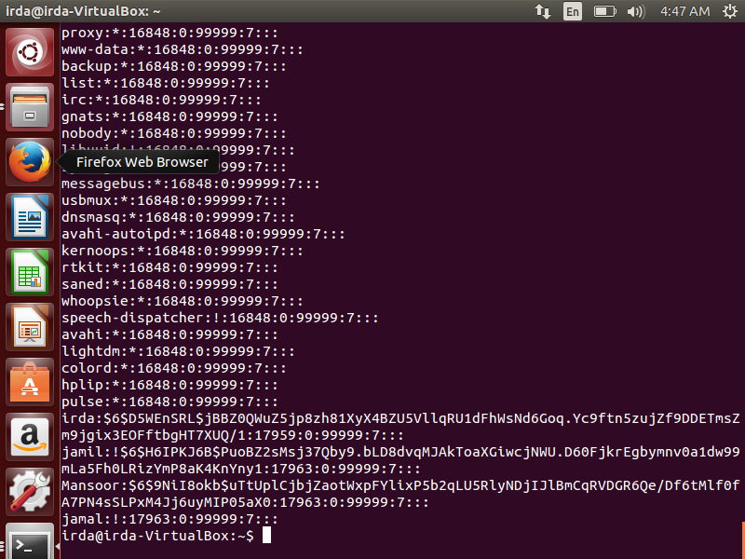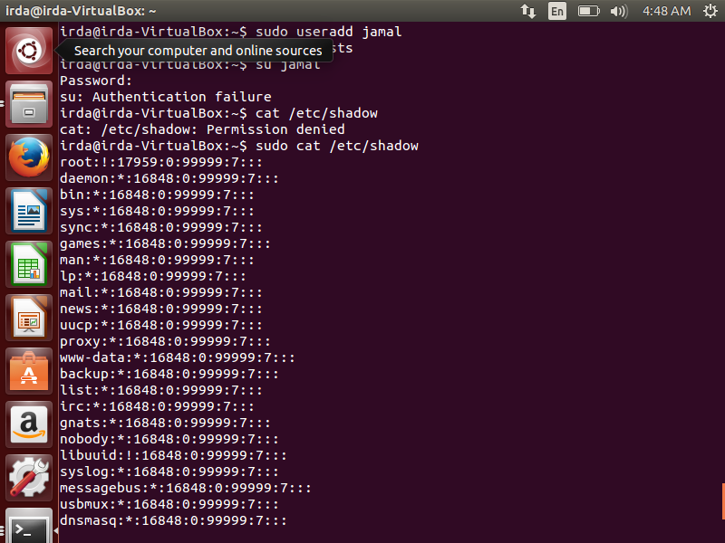

**TASK4**

1. Sudo groupadd sales

Sudo cat /etc/group

B) sudo groupmod -m marketing sales

Sudo cat /etc/group

C) sudo groupdel marketing

Sudo cat /etc/group

D) sudo useradd user1

Sudo cat /etc/passwd

Sudo cat /etc/group

E) sudo groupdel user1

f) sudo groupadd technology

sudo cat/etc/group

G) sudo useradd Hadeed

Id Hadeed

H) sudo usermod -aG technology hadeed

Sudo cat /etc/group

1. Sudo groupdel technology

Sudo cat /etc/group

J) sudo useradd Maaz

Sudo su Maaz

K) sudo usermod -ag technology Maaz

sudo usermod -g technology Maaz

Id Maaz

Sudo cat /etc/group

L) sudo groupdel technology

M) sudo groupadd cs

sudo groupadd mkt

sudo groupadd sales

N) sudo cat /etc/passwd

Sudo useradd xyz

O) id xyz

P) sudo usermod -aG cs xyz

sudo usermod -aG mkt xyz

id xyz

Q) sudo usermod -g sales xyz

Id xyz

Groups xyz

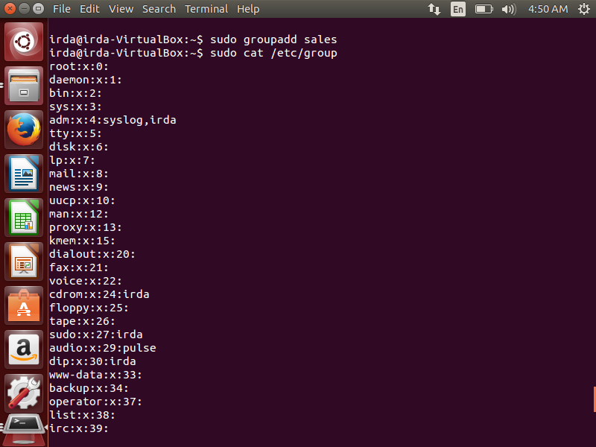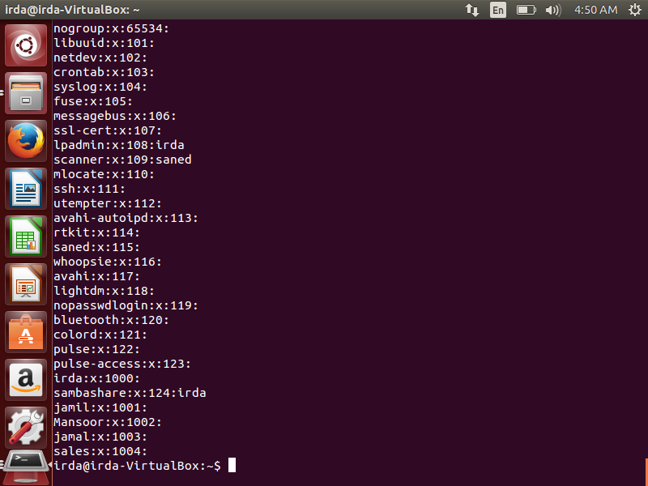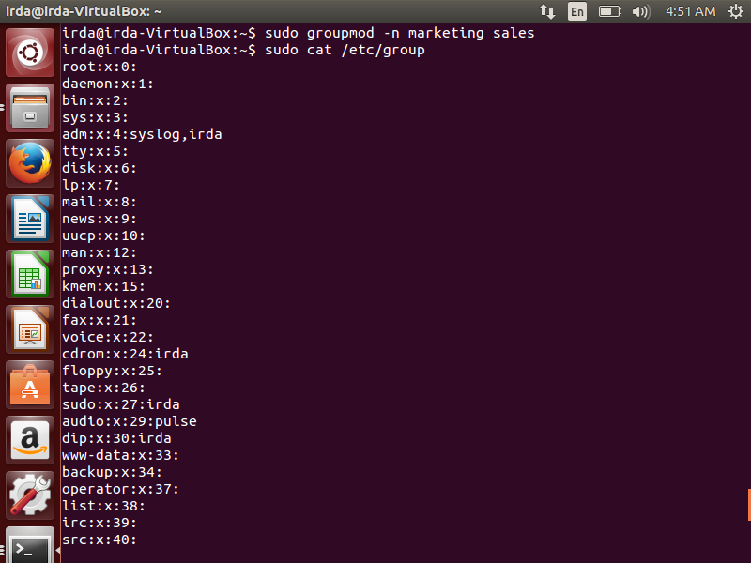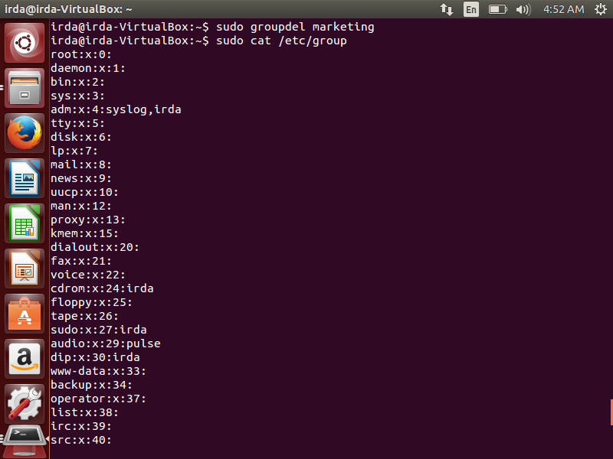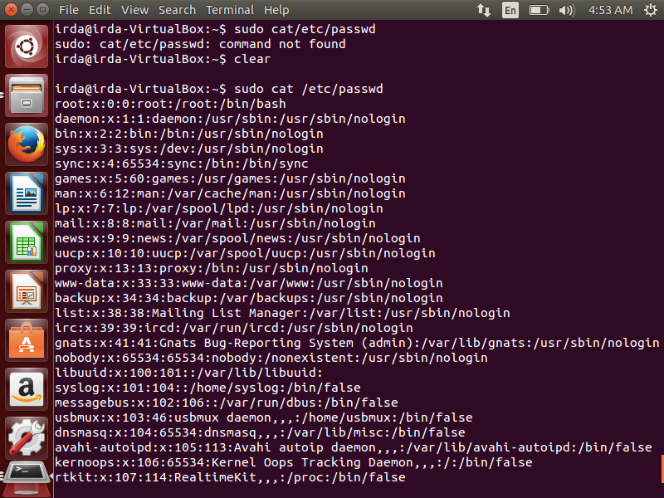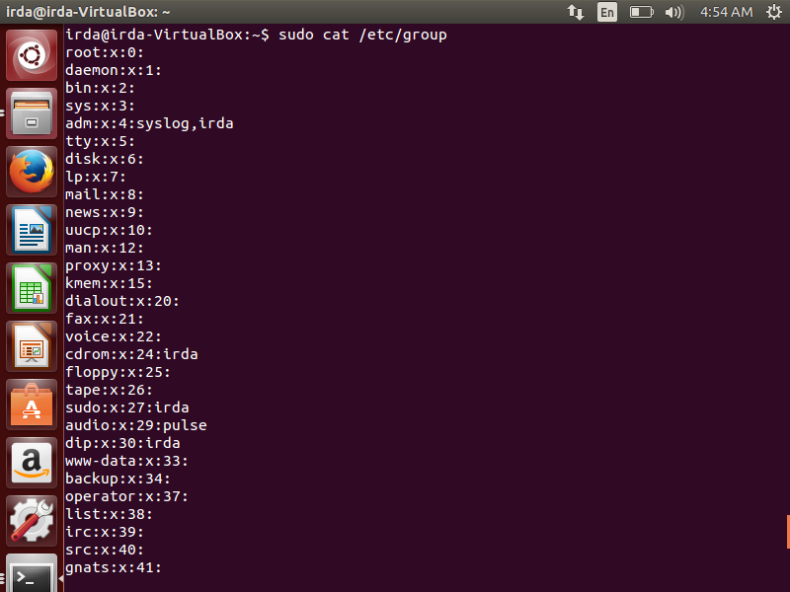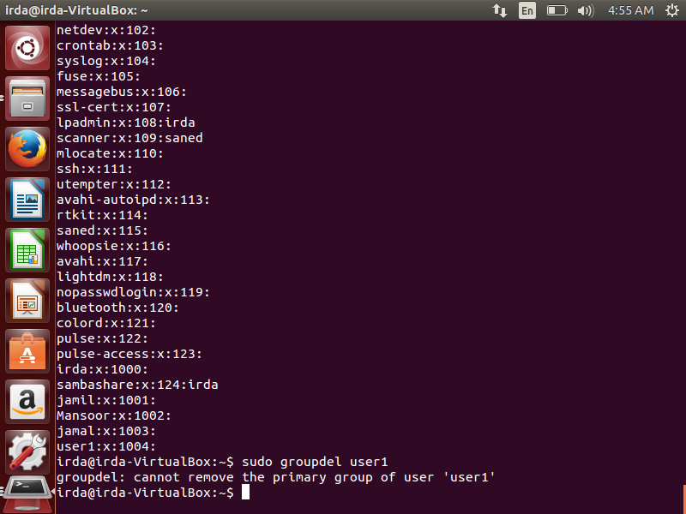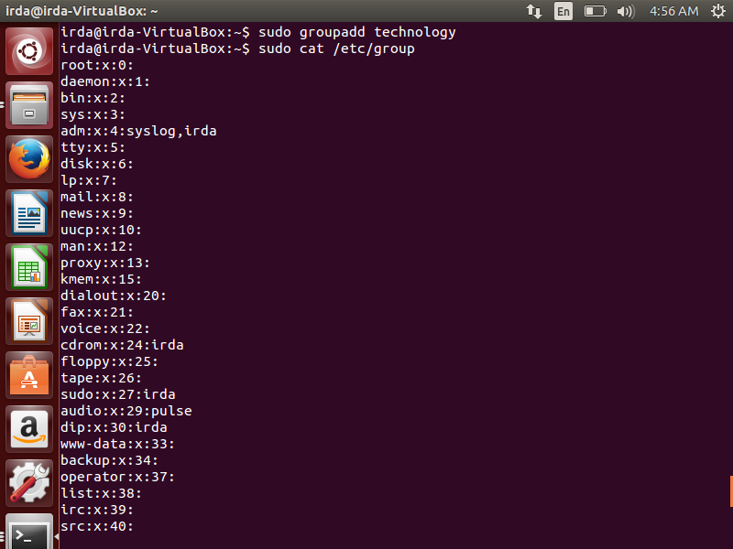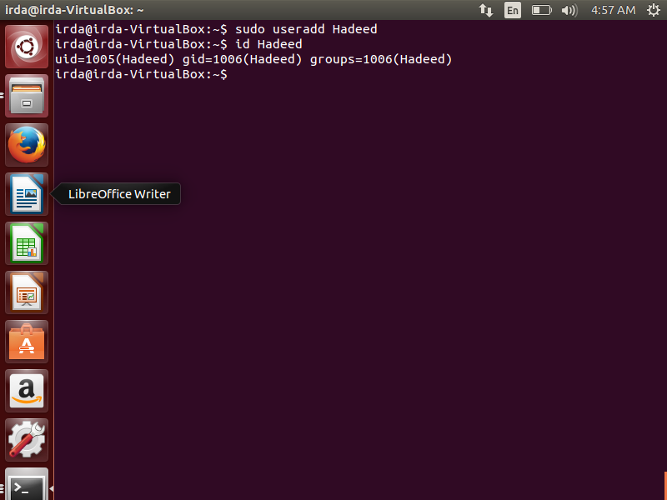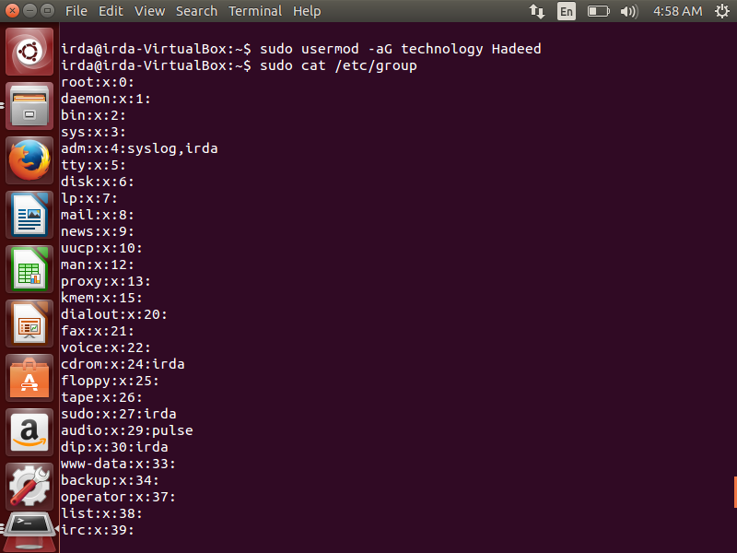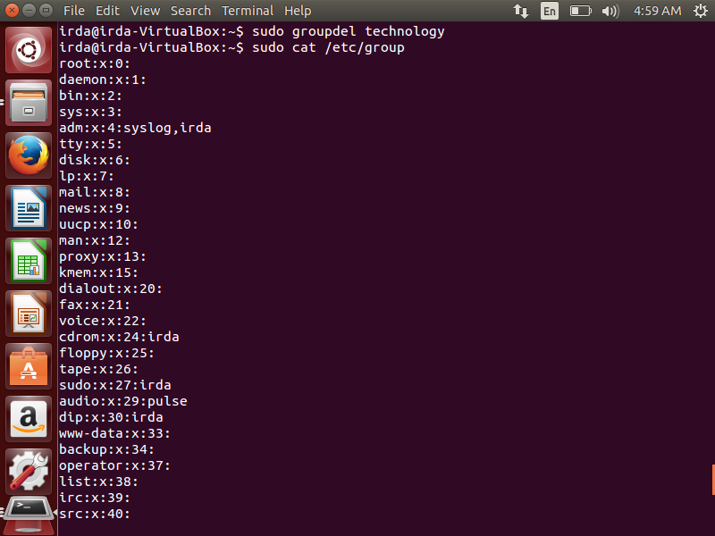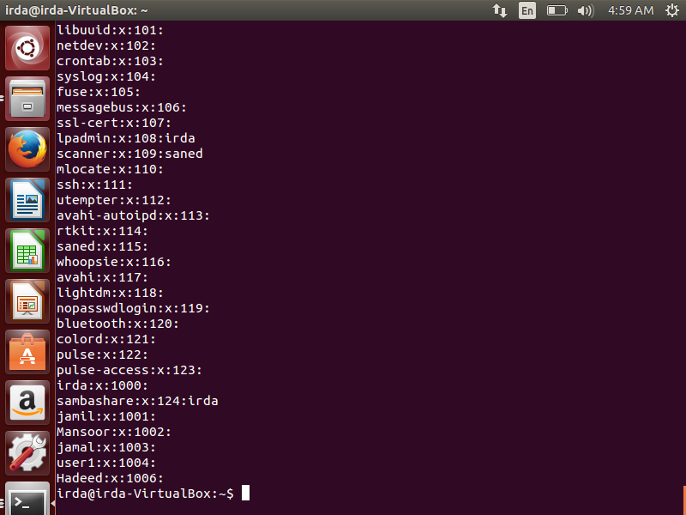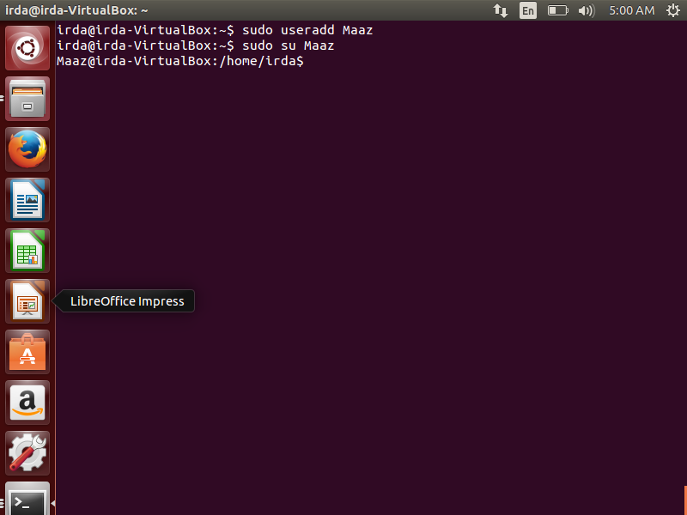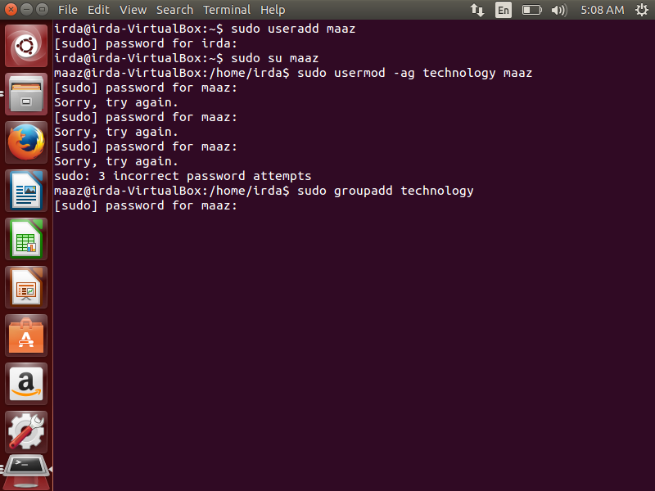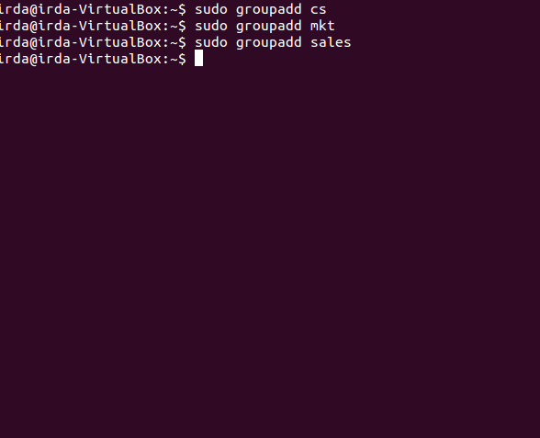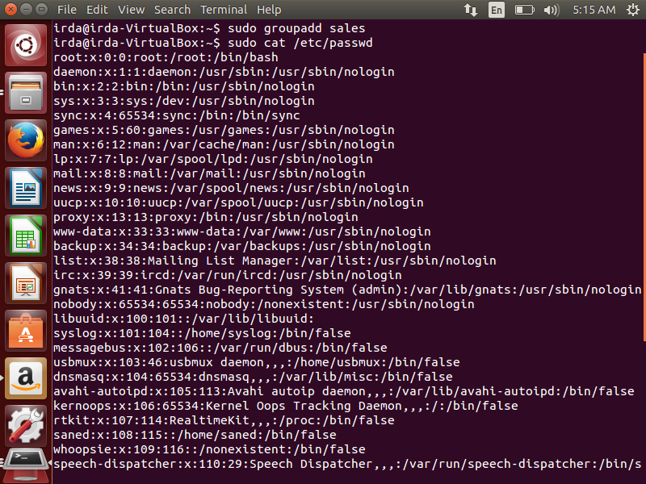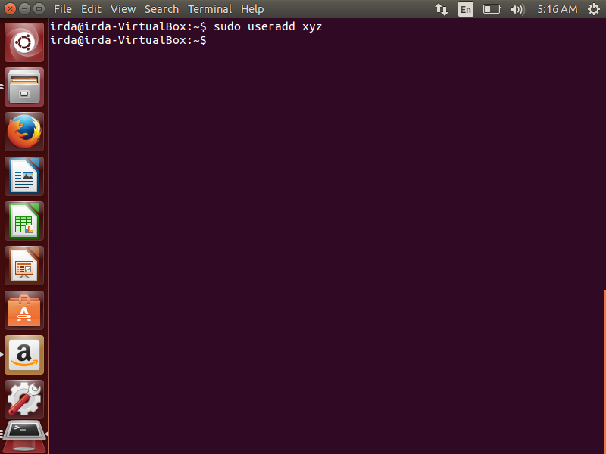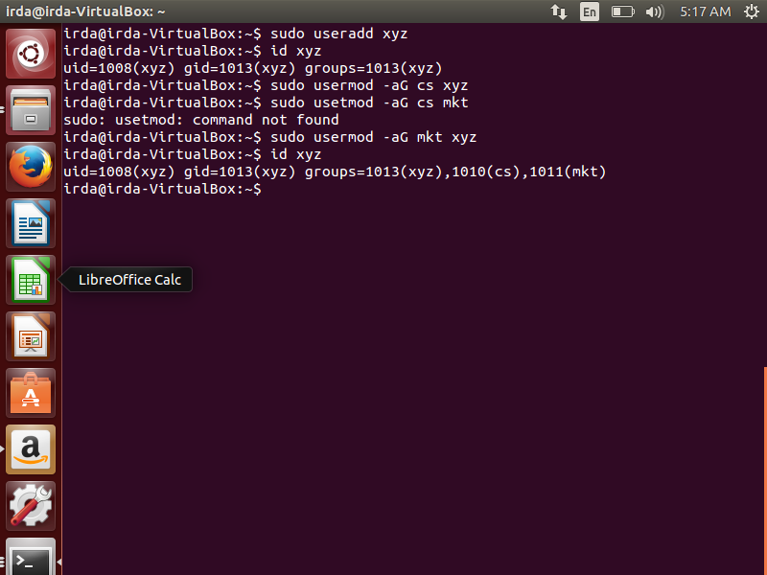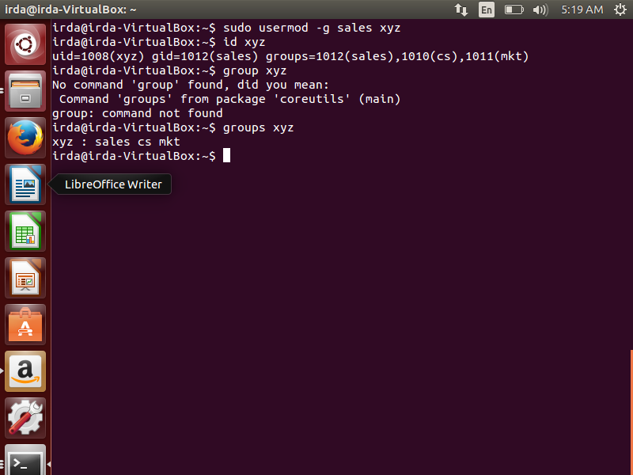

**TASK5**

1. Sudo su root

Useradd Khan

Useradd Tariq

Useradd Jamil

1. Su Khan

Mkdir ~/dir1

Touch ~/dir1/file1

1. Su Jamil

Cd /khan/home

1. Su Khan

Mkdir /tmp/dir1

Touch tmp/dir1/file1

Ls -l /tmp/dir1/file1

1. Su Tariq

Cd /tmp/dir1

Ls

1. Sudo su root
2. Su Khan

Ls -l /tmp/dir1/file1

1. Su Tariq

Cd /tmp/dir1/file1

Ls -l /tmp/dir1/file1

1. Su Khan

Chown Khan /tmp/dir1/file1

Chgrp sales /tmp/dir1/fil1

Ls -l /tmpdir1/file1

1. Su Tariq

Getit /tmp/dir1/file1

1. Su jamil

Getit /tmp/dir1/file1

1. Sudo su root

Usermod -aG sales Jamil

Su Jamil

Getit /tmp/dir1/file1

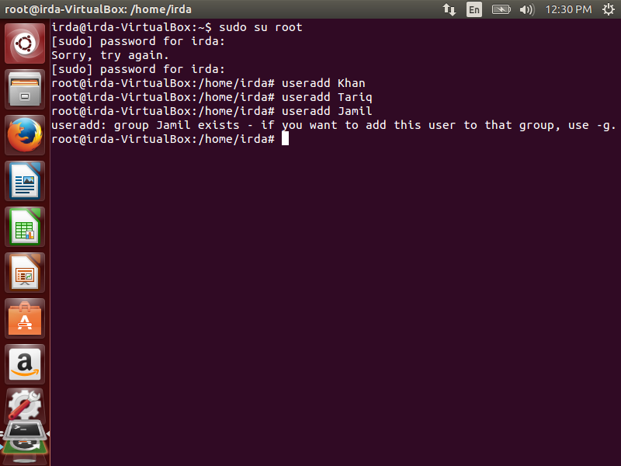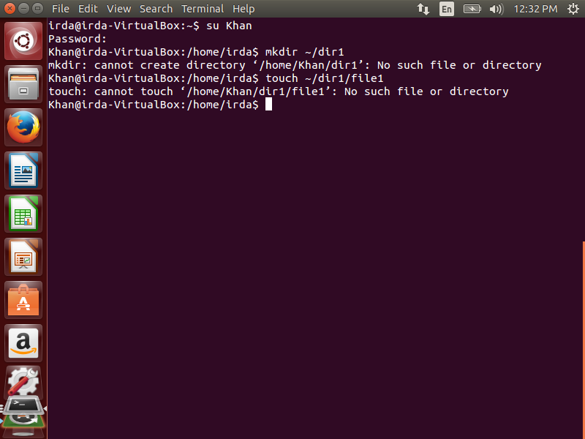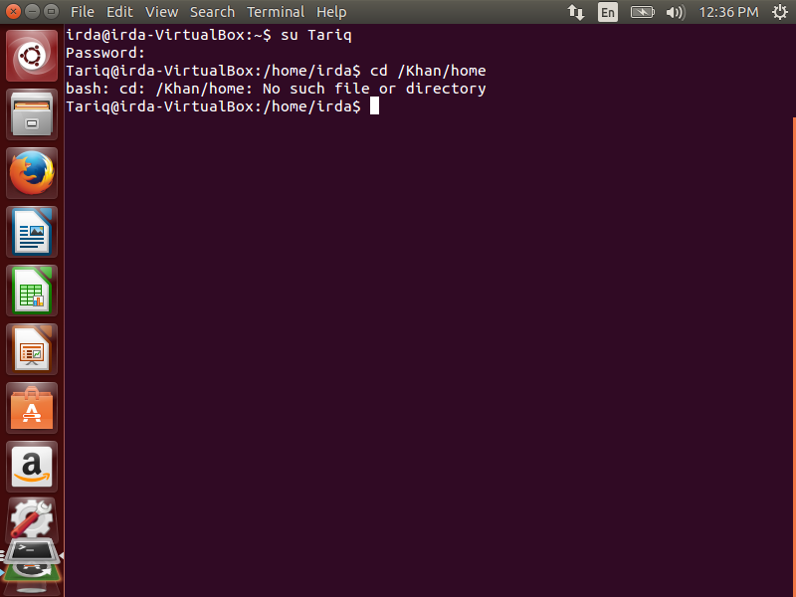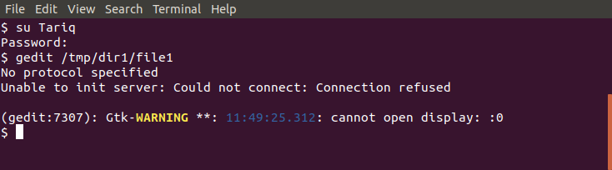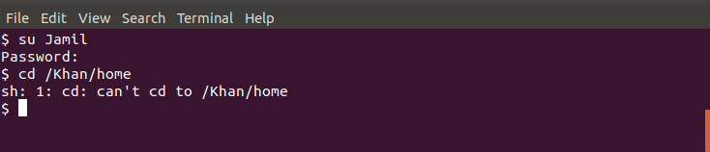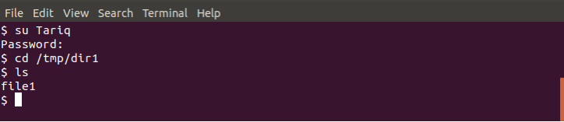

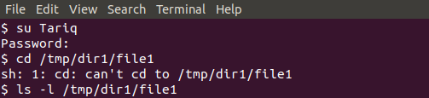

**TASK6**

1. Touch test1

Ls -l test1

Chmod o-r test1

Ls -l test1

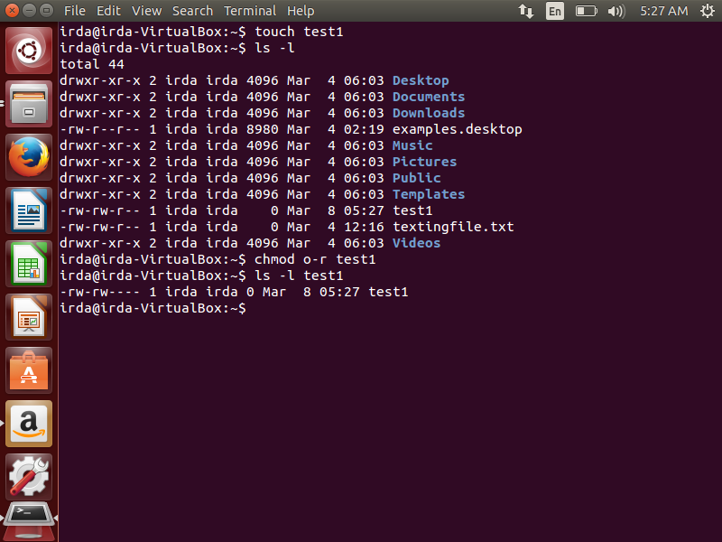

1. 1. Chmod 740 sets permissions so that owner can read,wrute and can execute. Group can read only and others can’t read,write or execute.

2. chmod u=rwx courses sets the permission of owner of courses to read, write and execute.

3. chmod 700 ~ also sets the permission of a user’s home directory as owner to all read,write and execute and forbids groups and others to do anything.

4. chmod ugo-rw sample doesn’t allow the sample’s owner, groups and others to do the reading and writing.

5. chmod a-rw sample Prohibits the sample’s owner, groups and others from reading and writing.

6. chmod a+x sample sets the permission of sample’s owner, groups and others to only execute.

7. chmod g=u sampleAssigns set of sample’s owner’s permissions to groups of sample.

8. chmod go= sample sample doesn’t allow the sample’s groups and others to do anything.

9. chmod 776 ~/lab5 sets the permissions of lab number 5 in home directory as read, write and execute for the owner and groups and only read, write for others.

10. chmod 751 ~/lab sets the permissions of lab in home directory as read, write and execute for owner,

read and execute for groups and execute for others.

1. 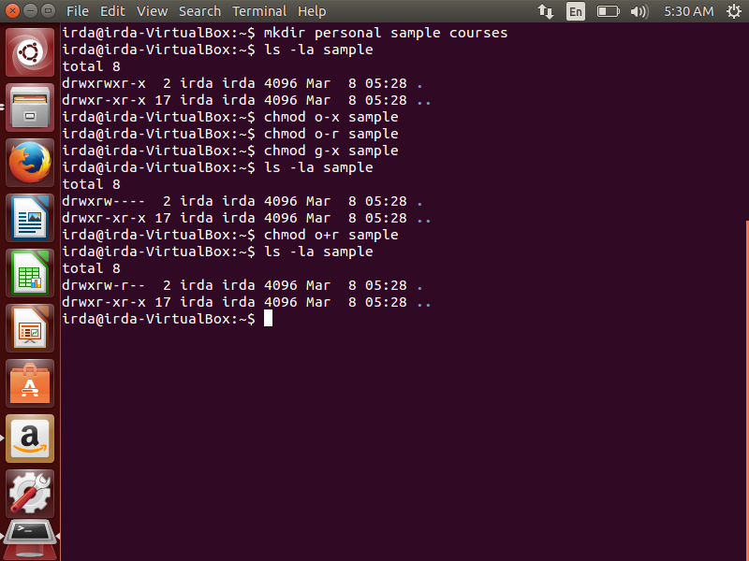
2. Yes, anyone can read this file as a home directory and file have the read permissions and as the home directory doesn’t give permission of writing and executing so nobody can be able to write or execute this file .